1-)
a)
Signal generator is turn off.

 | Part1 | Part2 | Part3
Dc Voltage drop across the 1kΩ | 30.91 mV | 3.82 | --------------
Vdq | 0.615 mV | 0.493 | --------------

b) Turn on the signal generator

PART1
Vin
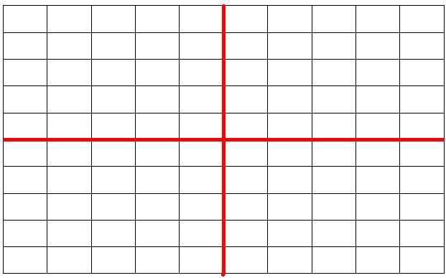

Vout

Part2

Vin

Vout

c)

 | Part1 | Part2 | Part3
Vm | 800 mV | 446mV | -----------------

d)signal generator 100mv peak-to-peak and vm=59mv

PART1
Vout&Vin

PART2
Vout & Vin

